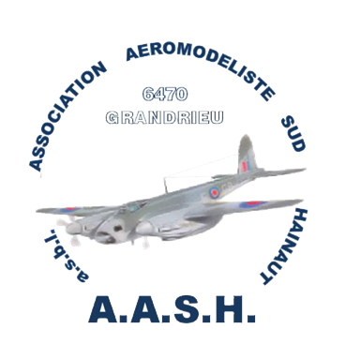

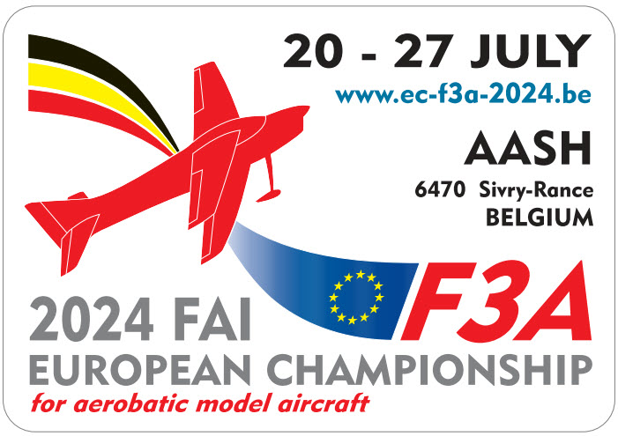

Biographical Information Form  Please send one form per person (Team-Managers and pilots only) | Country

Firstname
Firstname | Pilot |  | TM |  | Pilot & TM
Surname
Mobile number
Email-address
Please, write a short biography about yourself, your achievements, other hobbies or sports, interests, or your lifestyle, how many years in aeromodelling, how many years flying F3A, etc…. For printing in the contest event program | You can also choose to keep same text than for EC 2018 if  you was already pilot/TM.  Info from 2018 can be found here :  https://www.ec-f3a-2018.be/?page_id=48  Event information/Official program

Model Aircraft | characteristics
Aircraft Name |  | Engine  (manufacturer/type)
Designer |  | Prop and Pitch  (manufacturer/type)
Manufacturer |  | ESC  (manufacturer/type)
Wingspan |  | Battery  (manufacturer/type)
Length |  | Fuel glow  (manufacturer/type)
Weight |  | Spinner
Radio  (manufacturer/type) |  | Remarks
Receiver

Please return this form before April 30 th, 2024 to: werion.gerard@wanadoo.fr
in order to have the information in time for printing the official program.

