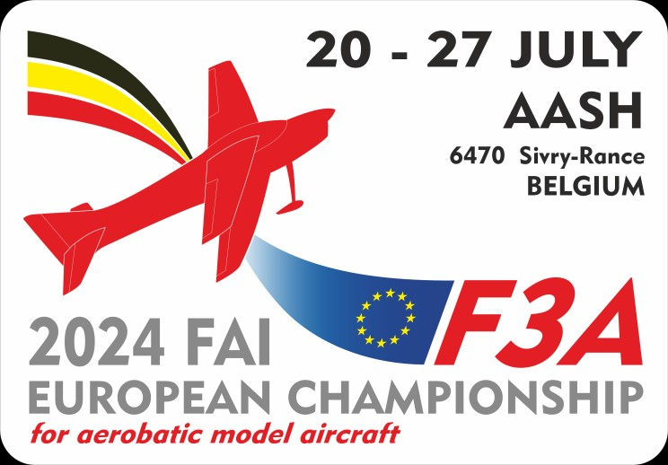
2024 FAI F3A European Championship
For Aerobatic model Aircraft
6470 GRANDRIEU – BELGIUM
http://www.ec-f3a-2024.be *
PRELIMINARY ENTRY FORM
Country Name
The National Aero Club (National
Airsport Control Organisation) of
intends to send a National F3A Aeromodelling team consisting of the following:
Name of Team Manager (if known)
Number of competitors
Name of Pilot 1 (if known)
Name of Pilot 2 (if known)
Name of Pilot 3 (if known)
Name of Junior Pilot as fourth member (if known)
Name of female pilot (if known)
Approximate number of Helpers/Supporters
Name to whom Bulletin 2 should be sent
Phone N°:
E-mail address:
* url not yet available

Signature of NAC official |  | Date:
Please return this form before February 1st 2024 to : AASH  Gérard Wérion  50 Rte Nationale  F-59216 BEUGNIES  France  E-mail: werion.gerard@wanadoo.fr |  | Seal of NAC

